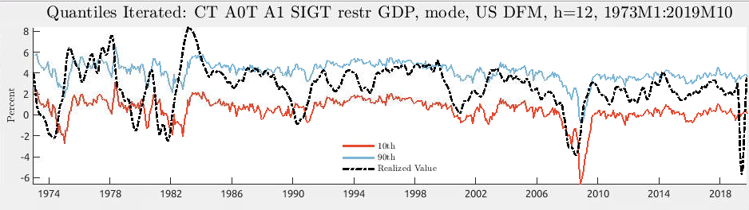

RISE forecasting routine Iterated model, exogenous transition probabilities

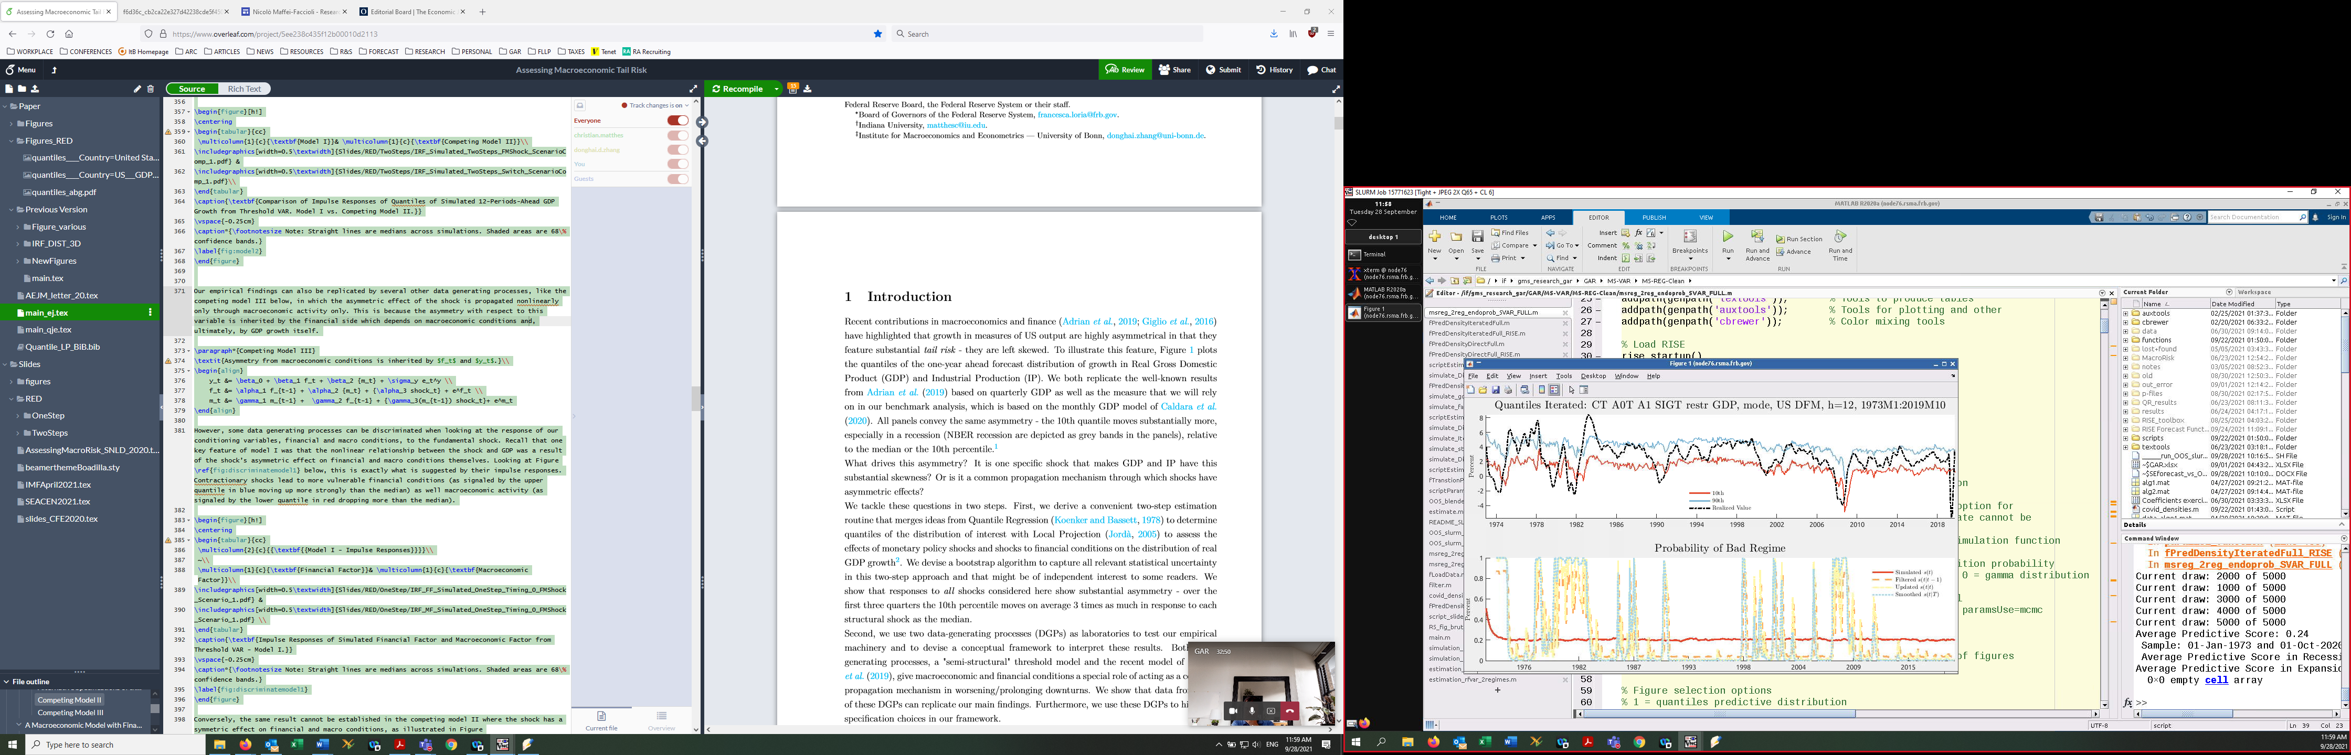

our simulation procedure, Iterated model, exogenous transition probabilities - forecastst

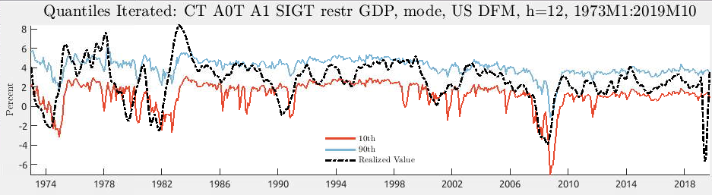

our simulation procedure, Iterated model, exogenous transition probabilities – drawst

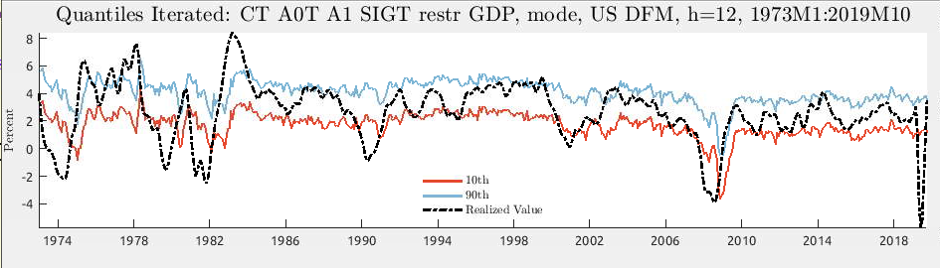

RISE forecasting routine Iterated model, endogenous transition probabilities

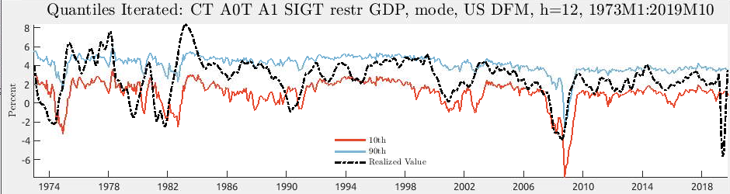

our simulation procedure, Iterated model, endogenous transition probabilities

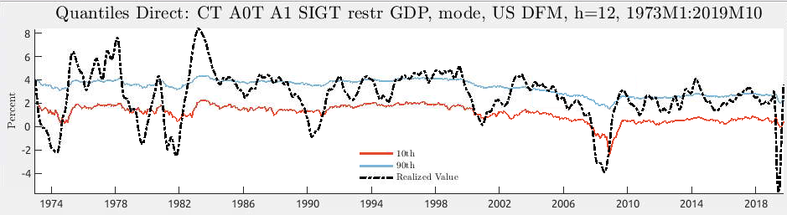

RISE forecasting routine Direct model, exogenous transition probabilities

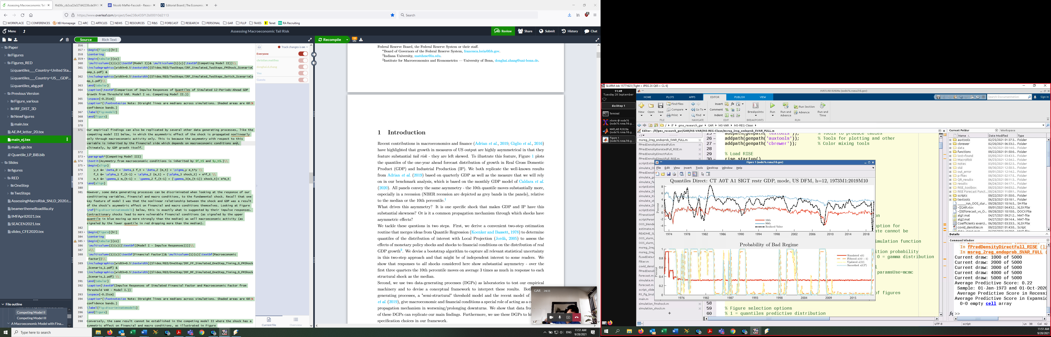

our simulation procedure, direct model, exogenous transition probabilities – forecastst

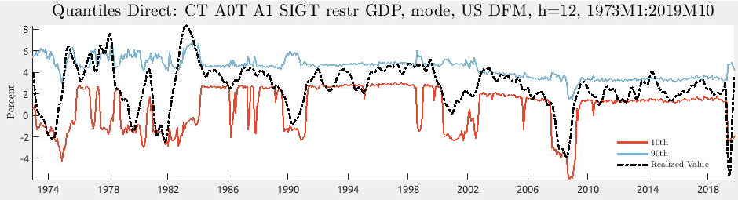

our simulation procedure, direct model, exogenous transition probabilities – drawst

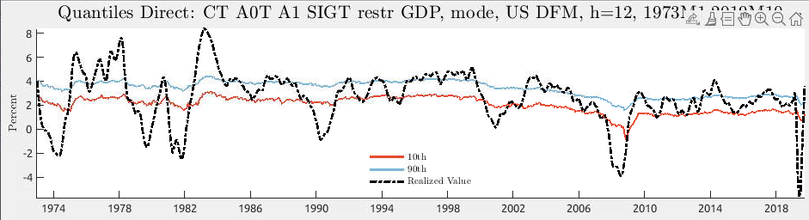

RISE forecasting routine Direct model, endogenous transition probabilities

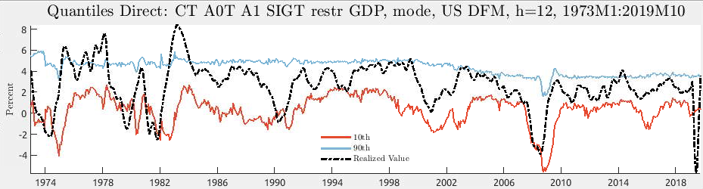

our simulation procedure, direct model, endogenous transition probabilities